One Day Reps Training Course
Participants’ Guide

Welcome
The EIS believes in training workplace reps across Scotland, in early learning and childcare settings, schools, colleges and universities.

EIS representatives are fundamental to the operation of their union and play a vital role for members in the workplace.

The EIS representative is not only a point of contact for members but also a point of contact for the national union and a conduit for communication between the two.

Most importantly, the workplace representative is the voice of members in the workplace.

This course will help you develop the skills to be an effective rep in your workplace, as well as discussing the support that you can rely on from all structures in your national union.

In this course we are developing your skills and the future of your union.

We look forward to getting to know you and supporting your role as EIS Rep.

Learning Objectives
By the end of the course, you will:
- Understand your role and rights as union rep in the workplace
- Understand union structures and points of contact for support
- Understand how to build your branch, including how to recruit and retain members
- Be able to identify different types of casework and the most appropriate support
- Understand collective bargaining and negotiating structures at school and Local Association level

Resources
The following resources will be helpful to you during and beyond the course.
- EIS Reps Handbook: https://www.eis.org.uk/Content/images/reps/eis%20reps%20handbook.pdf
- TUC ‘Role of TU Reps’ https://www.tuc.org.uk/resource/role-union-representative
- ACAS guidance on the role of a rep: https://www.acas.org.uk/acas-code-of-practice-on-time-off-for-trade-union-duties-and-activities/html
- Scottish Negotiating Committee for Teachers website: https://www.snct.org.uk/
- EIS website: www.eis.org.uk

Icebreaker
This section includes:
- Introductions
- Reflection on our motivations and experiences

Why did you decide to become a rep?

What qualities do you think union reps need to effectively represent and support members to make change in the workplace?

Section One: The EIS and the Role of a Rep
This section includes:
- The role of trade unions in the workplace
- EIS local and national structures

What do you think is the role of trade unions in the workplace?

What do you think is the role of trade union reps in the workplace?

Your Rights as a Union Rep
In this section, you’ll:
- Think about what facilities are needed to carry out your role as a rep.
- Understand your statutory rights as a union rep.

The ACAS (Advisory, Conciliation and Arbitration Service) Code of Practice of Trade Union Representation in the Workplace states:
Union representatives appointed by an independent union in workplaces where the union is recognised for collective bargaining purposes under the provisions of the Trade Union Labour Relations (Consolidation) Act 1992 known as TULR(C)A.
• Paid time off to carry out their duties
• Paid time off for training
• Protection against dismissal and detriment
The ACAS Code of Practice on Time-off for Trade Union Duties & Activities applies.
https://www.acas.org.uk/acas-code-of-practice-on-time-off-for-trade-union-duties-and-activities

Use this area to make any relevant notes

Our Local and National Structures
The EIS is a member-led union; members choose and direct union campaigns, policy and priorities at every level of the union.
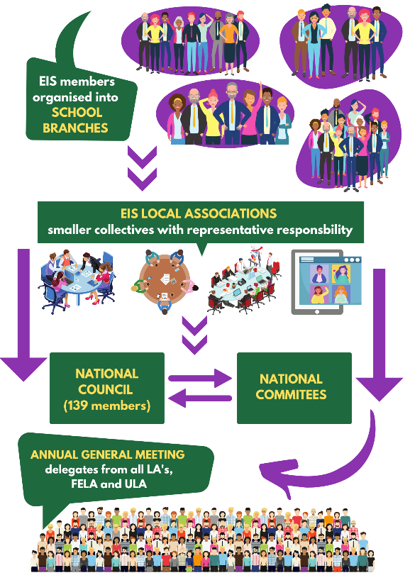

Section Two: Building Your Branch
In this section, you will:
- Discuss the importance of building a strong branch and recruiting new members
- Begin to think about the tools we can use to communicate with members
- Understand the importance of branch meetings and one-to-one conversations

What is a strong branch and why is it important?

How did your branch support the Value Education Value Teachers Pay Campaign and what was the role of the rep in this?

Recruiting new members
In this section, you will:
- Begin thinking about why some people may not want to join the union
- Build confidence in talking to members
- Practice finding out what members’ issues are and how to position the union as a solution

Why don’t some teachers join a union?

Activity: One-to-One Conversations
The best way to recruit new members is to speak to them one-to-one. Some people may be reluctant to join and so it is your job to take on board their concerns and persuade them to change their mind.
Split into pairs and using some of the reasons you have chosen above, one person should pretend to be a non-member of the EIS, and the other person should act as an EIS rep. As EIS rep, engage them in conversation to identify their issues at work and try to persuade this person to join the union, despite any concerns they may have.
Share your feedback with your partner.
Some advice:
- Try to listen more than talk; a good rule of thumb is to listen 70% and talk 30%.
- Introduce yourself as an EIS rep.
- Ask open questions to begin with so that the potential member starts talking, e.g. ‘Are you enjoying working here?’, ‘How are you finding things at the moment?’, ‘What are the three things that would make your work life better?’.
- Asking ‘why’ questions helps to get to the root of problems so that you can start thinking about solutions
- Position the union as the collective solution to their problems
Use this area to make any relevant notes:

Holding an Effective Branch Meeting
In this section, you will:
- Discuss the importance of running effective branch meetings
- Begin to think about what a well-structured meeting looks like
- Build your confidence to run branch meetings
- Begin thinking about what issues your branch might like to discuss at your own branch meeting.

It’s important to hold effective and inclusive branch meetings regularly to make sure everybody feels they have a voice in the decisions and direction of the union.

Think about the last meeting you had that that went really well. It could be a branch meeting or another meeting you were in.
- What happened?
- How did you feel?
- What did the meeting organiser do to make sure the meeting went well?

Think about your own branch meetings.
- How often do you meet?
- What are your branch meetings like?
- Do you feel all members have a voice in the meeting?
- What could you do to make the meeting better?

Section Three: Handling Members’ Problems
As a rep, you are the first point of contact in your school for members who need advice, assistance, or representation. As a fully trained rep, you may be required to handle cases. This may involve:
- giving general advice to members
- dealing with potential grievance and disciplinary matters
- negotiating on a member’s behalf
As a new rep, you won’t be expected to take on cases immediately, but you will be expected to refer cases to your Local Association Secretary who can deal with them. In the meantime, you should familiarise yourself with the processes.
If you decide there is a problem with which the union can help, there are sources you can check which will be available in schools. In addition to your EIS Representative’s Handbook there are local agreements (LNCT, Local National Committee for Teachers) and national agreements (SNCT, Scottish Negotiating Committee for Teachers). These cover all kinds of rights like pay, conditions, hours, sick pay, maternity rights, leave of absence, time off for special circumstances, and equal opportunities. There should be no difficulty gaining access to these documents, copies of which should be in your school or are available online Scottish Negotiating Committee for Teachers (snct.org.uk). As a rep, you’ll also receive regular advice and updated policies from EIS HQ, often along with the Rep’s Bulletin.

Supporting Members
There are three key steps in supporting members – sometimes called PIP:
- Identify the Problem – talk to the member
- Collect the relevant Information about the problem
- Plan how to support or refer the case

Identifying the Problem:
1. Try to find a quiet place for the meeting where you can talk privately without interruption.
2. Be sympathetic. Your member may be upset or angry.
3. Get all the facts. Whether it is disciplinary or grievance make sure you ask the following questions:
- when did the alleged incident or incidents take place?
- who was involved? (Including names of possible witnesses)
- where did it happen?
- what exactly was the nature of the problem?

In the case of potential disciplinary cases, if the member has not been made aware of the exact detail of any allegation you should ask for this to be provided by the Headteacher.
4. Make notes of the conversation.
5. Tell your member the member that you will think about the case and report back to them thereafter.
6. Collect further information (such as policies) and then either develop a plan using the information that you have collected or seek advice if the case is serious.

Activity: Handling Members’ Problems
Discuss the following scenarios.
How would you deal with each scenario? What facts would you try to get? What do you think the nature of the problem is? What skills would you use as a rep?
Case A
A member says that they’ve applied for a promotion three times and never been shortlisted.
CASE B
A member says that a promoted member of staff is treating him badly. Work is scrutinised daily and complaints are made about petty detail. The member also complains about pejorative terms to address him and very aggressive body language.
CASE C
A probationer teacher informs you that the head teacher came into her classroom and spoke to her about the noise level in her class in front of students. She is worried that the headteacher will take further action and the potential impact on her career.
CASE D
A history teacher has been deemed surplus to requirements of the school. She asserts that she was deliberately targeted and the selection is unfair.

Section Four: Collective Bargaining and Negotiation

We can all achieve more together than we can alone. When we stick together, we’re much more likely to win the changes we want to see.
Collective bargaining is the process of negotiation that trade unions and employers carry out in order to come to an agreement that applies to a group of workers. Negotiation is the process by which the employer and TU establish an agreed output, eg agreement or decision. In negotiations the parties are equal and the responsibility for an output is jointly held between the two parties. [It is distinct from consultation where the responsibility for decision making lies with the employer.]
As an EIS member, your terms and conditions are negotiated at the Scottish Negotiating Committee for Teachers (SNCT) and your Local Negotiating Committee for Teachers (LNCT).
The SNCT is a tripartite negotiating body whose members are drawn from the Convention of Scottish Local Authorities (COSLA), the Scottish Government and the recognised trade unions representing teachers in Scotland.
The SNCT requires there to be a LNCT in every council. Each union has representatives at the LNCT, including your LA secretary. The LNCT has the power to vary certain devolved matters locally.

National Matters (SNCT) | Devolved Matters (LNCT)
Pay (including related allowances)  The working week and working year  Annual leave entitlement  Class size  Sick leave  Maternity/family leave  National and local recognition procedures  Disciplinary and grievance framework  Main duties  Staff development framework  Notice periods | Other allowances  Cover agreements  Appointment procedures  Particulars of employment  Expenses of candidates for appointment  Transfer of temporary teachers to permanent staff  Promotion procedures  Staff development arrangements  Specific duties and job remits  Arrangements for school-based consultation  Other leave and absence arrangements  Housing  Indemnification procedures  Discipline and grievance procedures

Negotiation can be a long or short process, and may involve leveraging the TUs position by campaigning in order to move the employer to an agreement point.

School Level Negotiations
As rep, at some point you’ll be expected to take on some negotiation – the most likely school-based negotiation is around the Working Time Agreement.
Negotiation is a method of resolving conflicting needs and wants. We often think of it as being a formal set piece affair but in fact negotiation is an everyday activity.

Working Time Agreement
A Working Time Agreement (WTA) is a collective agreement reached at school level between the trade union(s) and the headteacher.
WTAs cover how much of your time over and above class teaching and preparation is spent on activities such as:
- Workload reforms
- Parents’ meetings
- Reporting
- Staff meetings
- Additional time for planning, preparation and correction
- Formal assessment
- Professional review and development
- Trade union meetings
- Additional supervised pupil activity
- Flexibility

It should also inform the targets, time, and resources in a school improvement plan.
Each LCNT will offer guidance to schools in your area on agreeing a WTA. Once negotiations are completed, it is signed off as agreed by the Rep and Headteacher. The agreement is then binding for all staff.
All schools should have a working time agreement that is reviewed annually and governs the allocation of time for defined activities beyond class contact and teachers’ preparation and correction time.
At school level, the agreement should be in accordance with the advice agreed between the authority and the teaching unions. The most important aspect of the process is that it must have been negotiated and finally agreed by school management and teaching staff.

Activity: Negotiating the Best Outcomes
Working in groups - read the following statements.
Where 5 is completely agree, and 1 is completely disagree, decide how far you agree with the following statements, and give your reasoning.
- The aim in negotiation is to gain as much as possible/concede as little as possible.
- The most important thing in negotiation is an awareness of the balance of power 2
- The most important thing in negotiation is to know your facts. 3
- When fixing your objectives for a negotiation it is best to be as flexible as possible. 4
- Begin negotiation with a non-controversial topic to break the ice, but then get right to the point by tackling the most important item first. 3-4 (context)
- Encourage co-operation by putting all your cards on the table.
- Don't allow the other side to escape by adjourning, particularly if you've got them in a tight spot.
- Wear down resistance by insisting that each point is settled before you move on to the next.
- Show the other side you mean business right from the start by making it clear exactly what action you will take if they don't concede.
- If the other side make a significant concession, take the opportunity to improve on it if you can.
- If you think you've got a good result, reinforce your position for future negotiations by letting everybody know how well you've done.

Final Activity - Reflection
What are the three practical things that you’ll take forward in your role as a rep?

What are the three steps that you can take to further develop your skills as a rep?

